Computer Language Coding Concepts

System Events in Normal Notation
System can be displayed with the normal event notation, examples of which you will find below.

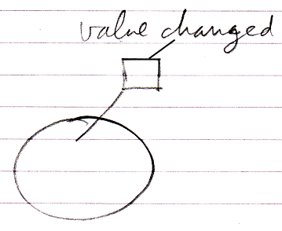

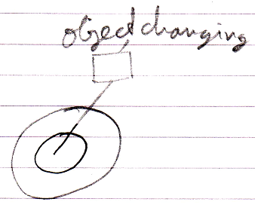

Author & Copyright: Jan-Joost van Zon Date: May 10, 2010 – May 14, 2010 Location: Oosterhout, The Netherlands Status: Finished

